|  |  |  |
| --- | --- | --- |
| 1/16/2015 | | Print |
|  |  | |
|  | Subject: Olacabs Invoice for CRN 30572046 | |
|  |  |  |
|  | From: | Olacabs Booking (noreply@olacabs.com) |
|  |  |  |
|  | To: | yashu_150@yahoo.co.in; |
|  |  |  |
|  | Date: | Wednesday, 14 January 2015 7:43 PM |
|  |  |  |



OLA INVOICE NO.30572046

14 Jan, 2015

OLA yashwanth

Thanks for using OLACABS



|  |  |  |  |  |  |  |  |
| --- | --- | --- | --- | --- | --- | --- | --- |
|  |  |  |  | TOTAL AMOUNT |  |  |  |
|  |  |  |  | ₹892 |  |  |  |
|  |  | TOTAL DISTANCE: 48.0 Kms | | | |  |  |
|  |  |  | TOTAL WAIT TIME : 11 Mins | | |  |  |
|  |  | OLA MONEY DEDUCTED | | DISCOUNT | PAYABLE AMOUNT |  |  |
|  |  | ₹0.0 |  | ₹0.0 | ₹892 |  |  |
|  |  |  |  |  | |  |  |
|  | FARE BREAKUP |  |  | FARE DETAILS | | |  |
|  | Base fare for 30 kms: | ₹540 | Total Payable Bill | | ₹892 | |  |
|  | Rate for 9.0 kms: | ₹234.0 | TAX BREAKUP | |  |  |  |
|  | Wait time charge for 11 Min: | ₹43.0 | Service Tax | | ₹29.03 | |  |
|  |  |  |  |
|  | Peak time charge | ₹0.0 |  |  |  |  |  |
| https://in-mg61.mail.yahoo.com/neo/launch?.rand=7dvu7f1291ib2#5073363924 | |  |  |  | 1/2 | |  |

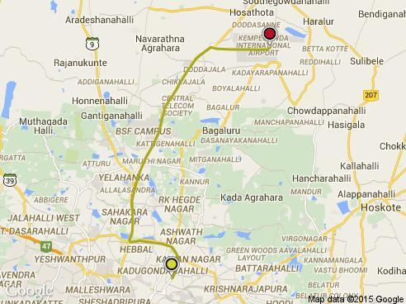

1/16/2015 Print

|  |  |  |  |
| --- | --- | --- | --- |
| Toll Charges | ₹75 | Education Cess | ₹0.85 |
|  |  | SHE cess | ₹0.29 |
|  | BOOKING DETAILS | |  |
| Service type | Bangalore, Cab, Mini |  |  |
| Booking Date | 14 Jan, 2015, 04:30 pm | |  |
| Pickup Date | 14 Jan, 2015, 07:43 pm | |  |
| Booking Email id | yashu_150@yahoo.co.in | |  |

*Minimum bill of ₹540 for the first 30Kms and ₹13/km thereafter. Wait time charges at ₹2.0 per min after first 10 mins , includes waiting time during the trip.

*Total Bill Payable is inclusive of service tax.Toll charges are included in bill.*

For further queries, please write to support@olacabs.com

Note: This is an electronically generated invoice and does not require signature. All terms and conditions are as given on

www.olacabs.com.

A Wing’ Sunteck Centre, 37­40 Subhash Road, Off. Western Express Highway, Vile Parle (East), Mumbai - 400057

Service Tax # AAJCA1389GSD001, Service Tax Category Cab Operator, PAN No. AAJCA1389G,CIN:U72900MH2010PTC240894 Tel: +91 22 3355 3355, Fax: 022 30947974 www.olacabs.com

©ANI Technologies Pvt. Ltd

|  |  |
| --- | --- |
| https://in-mg61.mail.yahoo.com/neo/launch?.rand=7dvu7f1291ib2#5073363924 | 2/2 |